`
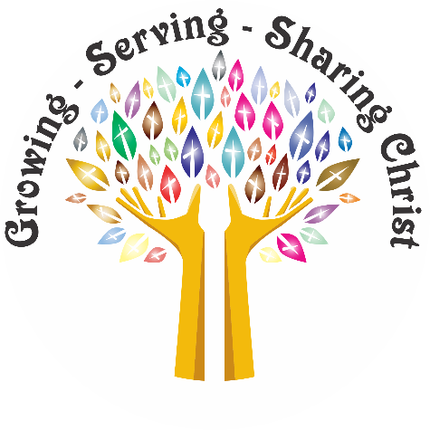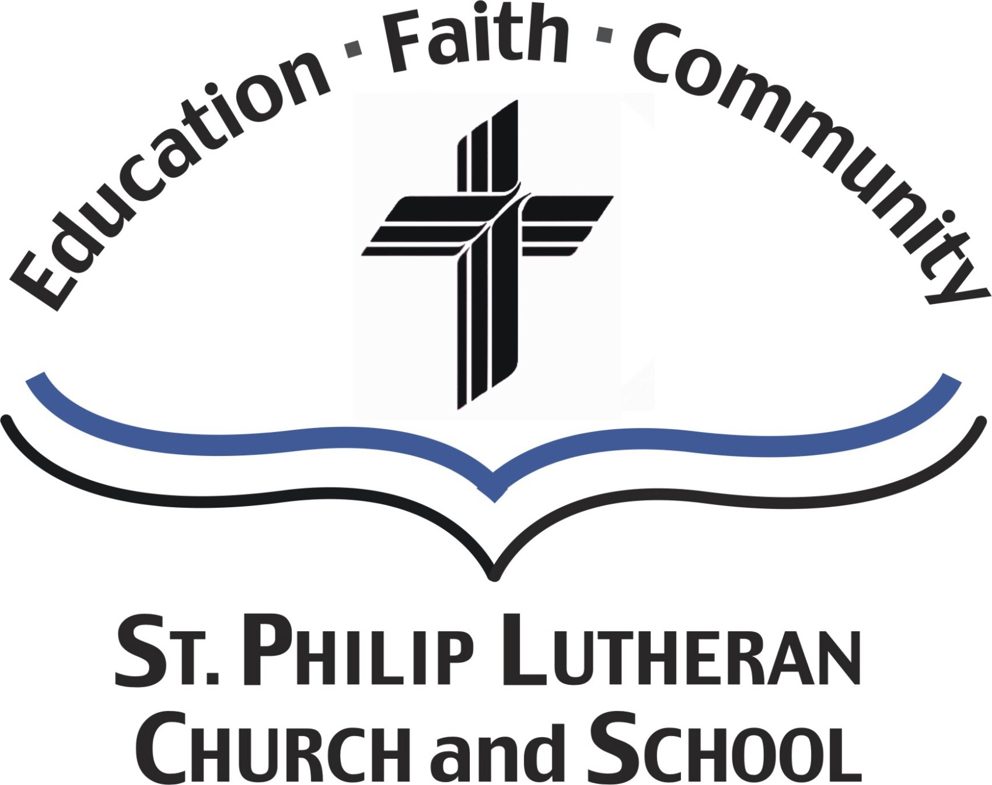
Our Mission ……….

Growing, Serving, Sharing Christ
Saint Philip Lutheran
Church and School
2500 WEST BRYN MAWR AVENUE - CHICAGO, ILLINOIS 60659
Church & School 773.561.9830 FAX 773.561.9831
Early Childhood Center 773.561.7566 FAX 773.561.3048
www.stphiliplutheran.com

The Pastor’s Page
Pastor Tom Engel

What We Live By

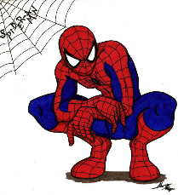
Around the corner from by my house, a little boy plays often out on the sidewalk. I see him whenever I walk my dog, and I call him Spiderman because he is always wearing at least a Spiderman t-shirt, or if not t-shirt, he is wearing a whole Halloween like Spiderman costume. When I pass by him, it looks like he is playing some game where he is battling it out with some bad guy. I say, “Hey Spiderman, how’s it going?” He smiles at me, but he also gives me a look that seems to say, “Can’t you see that I’m saving the world from the latest villain? Please don’t interrupt my work, or the bad guys will take over our fair city.”


Although our neighborhood is relatively safe, it is still a city where crime can happen, so I like the idea that I have a superhero just around the corner from me. Looking back at my childhood, I also ran around in my yard saving the world from some bad guy, except my favorite superhero was Batman. I liked all the gadgets that Batman had on his belt. In my imagination, my belt had all kinds of gizmos that propelled me to high places to dodge blows from the villain’s gang of hooligans, and of course, my bike had rockets that raced me around my neighborhood to help any person in danger from the evil foe.

As I got older and more mature, I dropped all my superheroes from the comics, and I went to someone more real, James Bond. I still have to say that I am always waiting until the next James Bond movie is out,

and like with Batman, I wonder what the new gadgets that James Bond will use to fight his adversary. Maybe that is the idea I need to pitch to Hollywood-James Bond and Batman Save the World. As adults, we tend to

forget our perspective that we had of the world when we were children. As children, we walked around looking up at everything. The world is basically made for adults, so as children we were always reaching up and looking up at things and people.

Seeing that everything is bigger than ourselves can lead to feelings that can overwhelm us, especially when we were small children. Like the little boy around the corner from me, children will build in their imaginations defense mechanisms to battle all the things in the world that is bigger than them. As Spiderman, my little friend around the corner has built in his yard with his Spiderman costume a world where he has the power to keep himself safe.

Not to over analyze the role and purpose of having superheroes, because for the most part, I am sure the little boy playing Spiderman was just having fun, and as adults, we watch the latest Avenger movie for only our entertainment to escape our present realities for a few hours. But I can’t help but think that after we walk away from having seen strength and power that is far above our own human abilities that we want at least some of this super power in our lives as we fight our battles in life.


I have a theory that we have a feeling for the need for extraordinary power in our lives that is very similar to what we needed in childhood. After all, life is tough. We must admit at times that life seems like it gives us more than we can handle. Our egos might find it difficult to say that we can’t handle something that is hard because we want to appear that we can carry the world on our shoulders. I am all for that we can “pull ourselves up by our boot straps” in the sense that we are to persevere and find ways to better ourselves, especially in hard times.

I do not like the idea of giving up on anything, and I even like the inspiring thought that we can be self-made people. We hear stories of people coming to this country and making something out of near nothing. As much as I like the grit of athletes who train vigorously to win, the diligence of students who knock themselves with hours of study to get the grades to get their dream job, and the industrious people who run businesses that create jobs for communities, I believe that the human spirit has its limits.

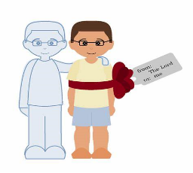
As a matter of fact, if the human spirit has any power, it is only because it has been charged up by another power. I will get to that other power that is most essential in a minute. Out of curiosity as the saying “pulling up oneself by your bootstraps” came into my mind, I decided to google the phrase. When the phrase first came out, it was meant to be ludicrous. A person can pull their boots on by bootstraps, but it is impossible for a person to pull himself up by his bootstraps.

In our time, we do not think it is absurd that a person can pull himself up on his own, and our egos do try to convince us that we have power within ourselves to accomplish anything. Whenever I go to see my favorite team, the Chicago Cubs, play and game, and when they are struggling, I want to say put me in coach. I always wanted to play baseball, but I have to admit I lacked some talent. Even with tons of practice, I was just not meant to be a pitcher.

The human spirit has its limits, but we do have limitless power in life to move and have our being and that power is only by the power of the Holy Spirit.

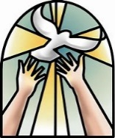
We cannot do anything except by the Holy Spirit. In seminary we had an elective course that we could take in addictions. I took the course and one requirement was to attend several AA meetings. I learn about Bill W. the founder of Acholic Anonymous. He found that in trying to overcome his addiction to alcohol that he could only do it by a higher power. For him, he lived by his faith that took him to the power of God in Christ that was given to him by the Holy Spirit.

St Paul talks about how there is one thing that he does that he ardently does not want to do but does do it. I always thought that the way that he states his problem that it sounds like he has an addiction. Maybe he writes about this one thing and does not tell us what it is because he knows that all humans struggle with something. We might not call that one thing an addiction, but we do have our issues in life.

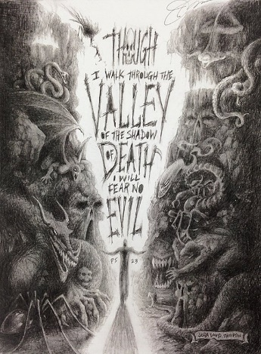
King David writes about walking in the valley of the shadow of death. In looking at the world about us, we have to say that our world is chaotic, messy, and unsafe. When we walk out the door, we are vulnerable to all kinds of threats and dangers. But we still walk out our doors every day because we know that we can get through each day.

David did not say that there was no evil in the world. What he did say was that he would not fear it. The reason that he would not fear anything was that he knew he had a higher power watching over him. He knew that Lord was with him every step of the way.

A big question in life is “What do I live by?” By what we live by determines how our lives turn out. If we live by fear, we will live too afraid to face the challenges that life offers us. These challenges are opportunities to live life fuller, but if we are fearful of what can lead to changes, even if these changes are better for us, we will lead very limited lives.

In so many places in Scripture, it says that we are not to be afraid. For instance, during the time of the birth of Jesus, God made sure Mary was confident about giving birth although she was a virgin, Joseph had the boldness to take Mary as a wife although he was not the father of the child, and shepherds could come and worship Jesus as the Savior of the world.

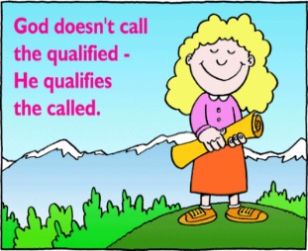
We, too, need to be confident in all the situations that God calls us to in life. By definition, fear is uneasy thoughts and feelings about what is unknown to us. At first, it seems our fears can protect us against what is bad in the world. Fear is a red flag that alerts us to danger, but we also need to know that nothing can harm us in life.

As Christians, our higher power is Christ who has defeated death, sin, and the devil when he died on the cross in our place for the forgiveness of our sins. Living by faith in all that Christ has done for us and the power that we have by the Holy Spirit, we can move freely and confidently in this world.

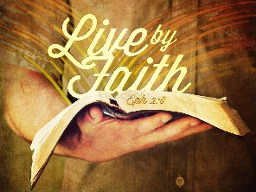
To be clear, living by faith will not make the world and not even necessarily our lives free from the chaos and the bad that evil wants to do. Living by faith will not always fix our problems and make life easier. When we live by faith and a true Christian love with others, our lives may get more difficult as some people in the world will reject our love in Christ as they refuse to understand this unconditional love.

We can count on with the greatest amount of confidence that when we live by faith, we will get through all the situations that come our way. Like St Paul after he did see himself giving into the thing that he did not want to do, he did see Christ, and he knew that in Christ and with the power of the Holy Spirit that he had true life.

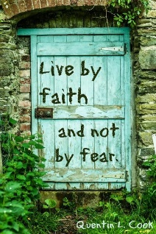
St Paul told a young Timothy as he was starting out in ministry not to have a spirit of fear but to have one of power. We know that St Paul faced many hardships in his ministry, so he wanted Timothy to do well, and he knew that the only way to do well was by the power of God. I cannot help but think that as St Paul was writing this to Timothy that he was also taking it all in for himself as he was in a tough situation.

St Paul spent most of his ministry in prison as he suffered for the spreading of the Gospel. He needed to hear the words of power from God to get through his situations. We need to tell others of the power of God because people are hurting in this troubled world. But we need to hear our own words of encouragement. Keep asking yourself the question, “What do I live by?” Then answer, “I live by faith of the power of Christ who is my strength given to me by the power of the Holy Spirit, and in this power, I can get through all things.”

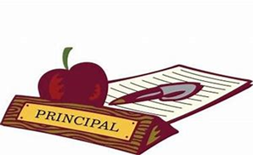

PRINCIPAL’S REPORT – NOVEMBER 2019
St. Philip Lutheran School + Chicago, Illinois

Recently, one of our eighth grade students hurt his ankle and required the use of crutches around school. Our younger students noticed this as he moved about the school. One of the kindergarten children asked, “Why is he (child’s name) on sticks? Her teacher explained those sticks are called crutches. A preschooler asked her teacher about his ankle. Her teacher said he had hurt his ankle. The preschooler was very concerned and asked if he needed a band aid, as she was ready to give him one of her band aids from home.

St. Philip is a caring community. Our size lends itself to older and younger children getting to know one another and caring for each other, as in the case of the preschooler offering a band aid to help the eighth grader heal. Intentionally designed activities allow for our older and younger children to get to know one another and ultimately create a caring community. Thanks be to God for these opportunities.

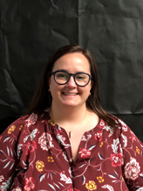
Meet the Newest Member of Our Team! St. Philip welcomes Mrs. Andrea Bateman as Director of Marketing and Enrollment. Thank you to the Chicagoland Lutheran Educational Foundation (CLEF) for assistance in funding this position.

In the short time Mrs. Bateman has been on staff, she has been getting to know St. Philip and the neighboring community. She is diligently working on updates to our marketing plan, social media platforms, and the website. She is meeting with teachers, Commission on Education members, parents, congregation members, as well as leaders in our community. Mrs. Bateman wants to know what St. Philip is all about and would like to meet you. Please do not hesitate to reach out to Mrs. Bateman (abateman@stphiliplutheran.com) with your ideas and testimonials. She is usually on campus on Mondays, Wednesdays, and part-time on Fridays.

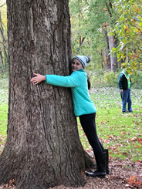
Fifth/Sixth Graders Venture off to Walcamp: In mid-October our fifth and sixth graders traveled to Walcamp in Kingston, Illinois. At Walcamp, they had a great time learning and playing in nature. The cool weather did not dampen the outdoor opportunities for learning how to use a compass during orienteering, nock an arrow in archery, identify trees and leaves, build a shelter for a survival unit, and learn about bats. Our students created a rap song about a bumblebee bat. Perhaps you saw it on Facebook. During the evening, the students observed the immense starry sky. Our students also got to know the sixth grade students from St Peter, Arlington Heights, who were also at Walcamp that week.

Overall, the students had a wonderful experience discovering God’s beauty while growing closer to one another. There was definitely lots of laughter and fun! A special thank you goes to Mr. Cader, who chaperoned the trip with Mrs. Tennis.

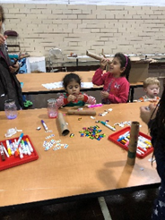
Night Under the Stars/Trunk ‘n Treat & Pumpkin Decorating: During October we held two special events. The Night Under the Stars committee put together a star-studded evening complete with finding constellations, making telescopes glow jars, food and fellowship. Students enjoyed eating their hot dogs in the starry classroom, and then going outside and using telescopes to view the planets and stars. We are thankful to the committee who made this an awesome event and donated their time and treasures.

The cold and drizzle did not stop our St. Philip school/church families and community friends from celebrating Halloween at our Trunk n’ Treat/Pumpkin Decorating event. Thank you to all who decorated their trunks and passed out treats to our numerous trick or treaters! We are grateful to Thrivent and the 20th police district for taking part in the trunk n’ treat.

The fun continued when the party moved inside for a costume parade, photo booth opportunities, eating hot dogs and pumpkin squares, and of course, pumpkin decorating. Thank you to City Grange for their support with the pie pumpkins used for pumpkin decorating. Families may want to bake their pumpkins after Halloween to make the delicious pumpkin squares. Thanks to Jennifer Miranda for making the pumpkin squares and sharing her recipe with families.

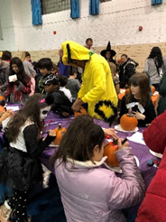
Thank you to the committee for all their ideas and volunteering their time, talents, and treasures. This was a very special evening for all, and brought many neighbors into our building.

These fellowship events build community both inside and outside the walls of St. Philip. Thank you to all who were involved in the planning, coordinating, set-up/clean-up and running of these events. Much time and energy is involved and we are so very grateful to these individuals.

St. Philip Celebrates Lutheran Schools Week: During the last week of October, St. Philip celebrated Lutheran Schools week with special dress up days and activities. Buddy reading time, the staff versus 6th-8th grade volleyball game, and a field trip to Feed My Starving Children in Libertyville was just some of the fun. This special week was a great reminder of our school year theme, Live Joy:fully, and to see how fully God has blessed and continues to bless this important ministry of our church.

Looking ahead to November: *November 13 at 7 p.m. Auction meeting:—initial planning—everyone is invited who would like to work on the committee
*November 17 following 10 a.m. worship: Outreach Cookie Bake—bring your favorite cookie recipe and ingredients to make cookies
*November 20 at 6 p.m.: Thanksgiving Potluck dinner—bring your favorite dish to share

Thanks be to God for His good gifts he bestows on us daily. May we use these gifts for service and His glory!

In Christ’s service,
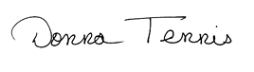
Donna Tennis
Principal

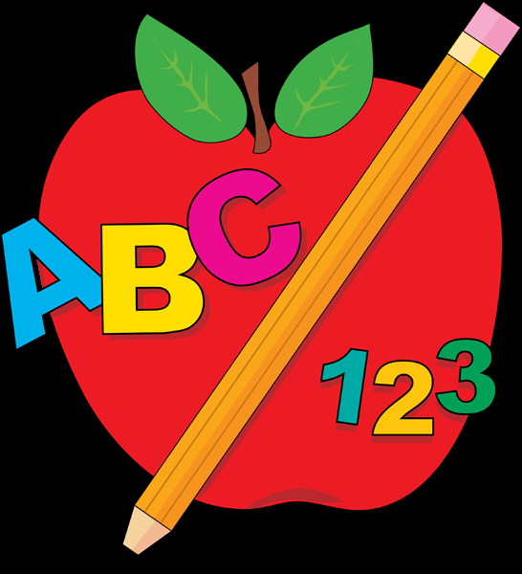



Scholarship Recipient Named
By Gloria Messerschmidt

The Rev. Dr. Victor C. Rickman Scholarship and Grant-in-Aid was established by Pastor Rickman’s family, members of The Lutheran Church of Saint Philip, Friends and Colleagues at the time of his Homegoing. Pastor Rickman was the 3rd Pastor of Saint Philip from 1941 – 1980. The Scholarship was in keeping with Pastor Rickman’s wish to financially assist young men preparing for the preaching Ministry at his Alma Mater, Concordia Seminary, St. Louis, Missouri. The guidelines of the Scholarship state, in part, that the recipient shall be a 4th year Seminarian who “has high academic achievement, demonstrates strong interest in the Parish Ministry and the art of communicating the Gospel of Jesus Christ to the person in the pew.”

This year’s Scholarship recipient is 4th Year Seminarian, Adam Wolfe. His home Church is Faith Lutheran Church, Germantown, Wisconsin. His year of Vicarage was at St. Lorenz Lutheran Church, Frankenmuth, Michigan. Adam will receive his Call on Call Night, Tuesday, April 28, 2020.

In correspondence received from Adam, he states, in part: “I want to thank you for the generous scholarship you gave me for this academic year. That is such a wonderful blessing and I appreciate it so much. I would not be able to afford going to the Seminary if it were not for generous people like yourself.”

Adam continues to write: “I am just returning from my Vicarage at St. Lorenz. It was such a great year and it has furthered my desire to serve Christ’s Church as a Parish Pastor. I married my wife, Morgan, in the Summer of 2017. Morgan is an early Childhood Teacher. We would love to be called to a Church that has a school as well!”

“Morgan and I love the outdoors, and, enjoy camping and hiking. We goth have been blessed with very supportive Families and Friends who have encouraged us to pursue our vocations to share God’s Word as a Pastor and Teacher in the LCMS. Your Scholarship for my secondary education enables us to do just that!”

God’s Blessings to Adam and Morgan during these Seminary days. Our prayers are with them, also, as they continue in their Ministry to God’s People!

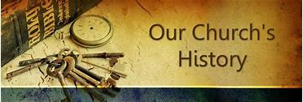

Do You Know That??
By Gloria Messerschmidt

. . . November, 1926, The Rev. Edward C. Kuehnert, was ordained and installed as the 2nd Pastor of Saint Philip.

. . . On Sunday, November 4, 1928, the laying of the Cornerstone, for our Church, took place in a Service at 3:00 P.M. The Rev. Edward Kuehnert, the 2nd Pastor of Saint Philip, was the officiating Minister.

The Cornerstone was taken from the “Old Church” and inserted into the Church wall facing the Interior Court. For a closer look at the location of the Cornerstone, walk out to the “Garden of Thanks and Remembrance” and look up at the South-West corner of Church.

The contents of the Cornerstone includes: 1) The Holy Bible; 2) Luther’s Small Catechism; 3) An English and German Hymnal; 4) The Constitution of Saint Philip and a brief history; 5) A list of Voting Members and Church Officers; 6) A copy of “The Lutheran Witness” and “Der Lutheraner” and “Mission Staube”; 7) The Synodical Handbook; 8) A copy of The Augsburg Confession; 9) Autographs of President Calvin Coolidge; Governor Leonard Small and Mayor William Thompson; 10) Copies of the main sections of “The Chicago Tribune” and “Sonntagspost”; 11) A write-up from “The Lincolnite”; 12) A picture of the “Old Church” at Lawrence and Oakley; 13) A copy of the Saint Philip “Herald.”

. . . Thanksgiving Day has been celebrated on the 4th Thursday of November ever since July 15, 1863, following the Battle of Gettysburg, when President Abraham Lincoln proclaimed it as
the National Thanksgiving Day. This year Thanksgiving Day is Thursday, November 28th.

. . . The Season of Advent comprises the four weeks preceding Christmas. This year the 1st Sunday in Advent is Sunday, December 1st.

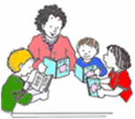
Senior Book Buddies
By Barb Uber

Join the Senior Book Buddies on Wed Nov 13th. We meet at 9am for fellowship.

After chapel we will read to the 3 and 4 year olds. You will enjoy yourself and the children love the individual attention.

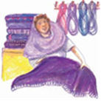
Lydia Guild
By Barb Uber

The Lydia Guild will meet Tuesday November 19th.
We will be preparing for our holiday sale on November 24. Come and enjoy the camaraderie and help prepare for a great sale. We meet at 6:30 for snacks and get down to business at 7 pm.



6 – Jody Nitti
9 – Joseph J. Eipl
Ingrid Wicklund
10 – William Johnson
11 – Kathryn Eipl
16 – Holly Cesena
21 – Christina Glaser
23 – Jane Tinder
24 – David Adams
25 – Travis Clarke
26 – Sarah Joseph
30 – David Joseph

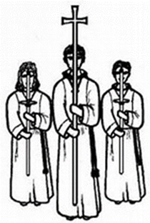

November Service Assistants

Nursery:

November 3 – Karen Huston
November 10 – Dee Dee O’Connor
November 17 – Karen Anderson
November 24 – Karen Huston

Lector:

November 3 – Donna Tennis
November 10 – Karen Huston
November 17 – Donna Tennis
November 24 – Lynn Walsh

Communion Assistants:

November 3 – Tom Paker & Matt Schau
November 10 – Tanner O’Connor & David O’Connor
November 17 – Chris Amundson & Brian Tennis
November 24 – Tom Paker & Matt Schau

Acolytes:

November 3 – Hannah S
November 10 – Emily Schau
November 17 – Emily Schau
November 24 – Hannah S

Deacons & Ushers:

November 3 – Joe Eipl (Deacon)
November 10 – Joe Eipl (Deacon)
November 17 – Joe Eiple (Deacon)
November 24 – Joe Eipl (Deacon)



Fall Happenings from Girl Scouts

October 26
Founders’s Day Campfire
Emily Oaks Nature Center

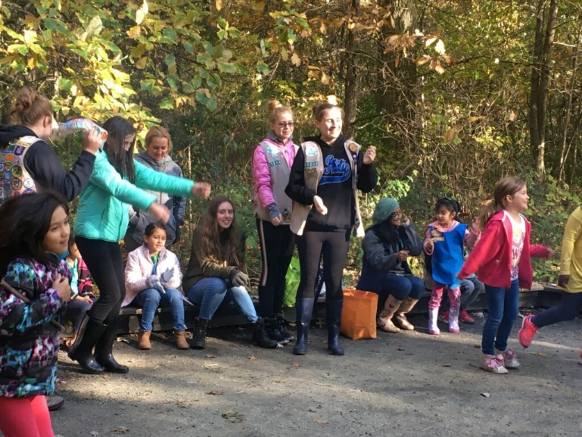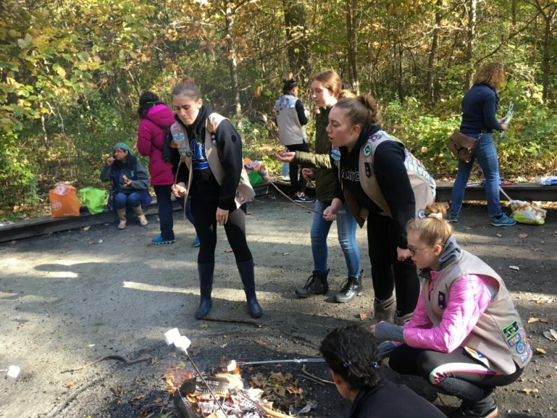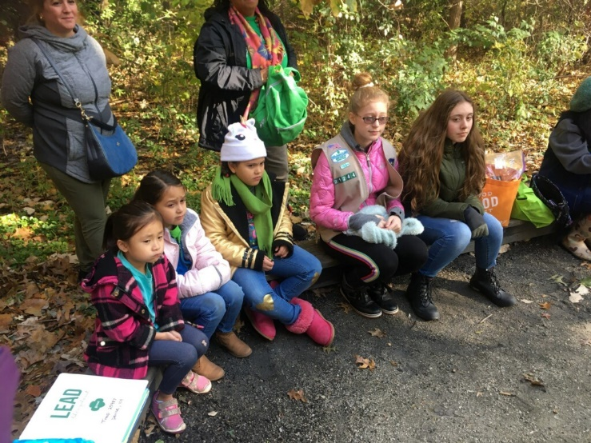

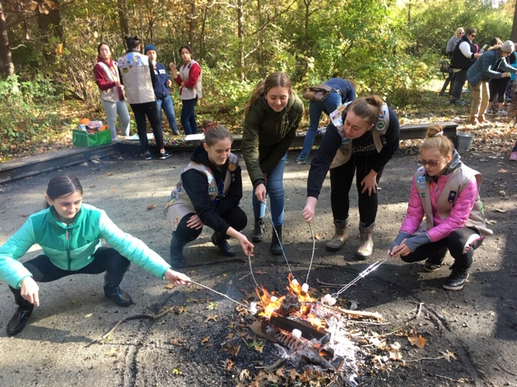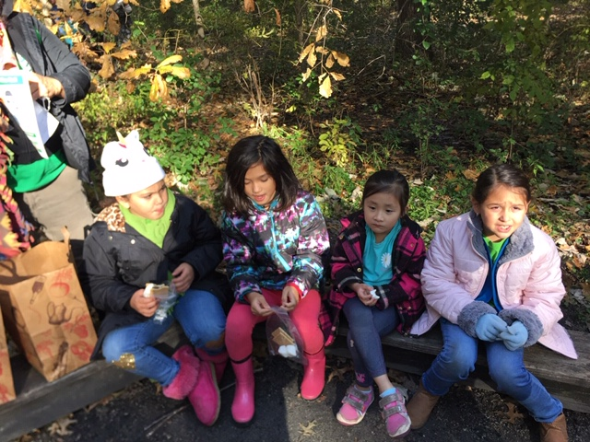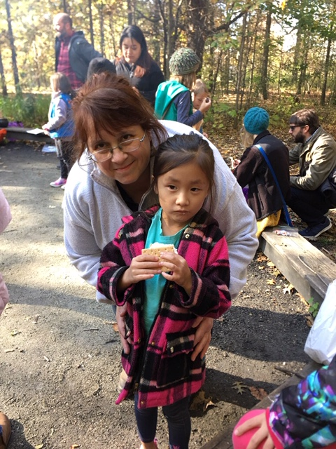

Pumpkin Volcanoes



